CONSUMERMOJO.COM MORTGAGE GUIDE

by Barbara Nevins Taylor

WHAT YOU NEED TO KNOW:

IF YOU’RE A FIRST TIME HOMEBUYER,

BUYING A HOME AGAIN, OR

LOOKING FOR A REVERSE MORTGAGE,

INTRODUCTION

We’re all in the same boat when we shop for a home. Whether it’s a big house, small house, townhouse, condo or co-op the details of getting a mortgage to make the purchase are the same.
Unless you’ve got a stash of cash or a rich relative, you need to get a loan from a bank. When interest rates are low even rich people with easy access to their own money often use the bank’s capital to finance their purchase so they can use their money for other investments.

WHAT’S A MORTGAGE?
A mortgage is another name for a loan. This type of loan is secured by a property.

When you borrow, or get a mortgage, you make the lender your partner for 15, 20 or 30 years depending upon the terms of the mortgage. The contract requires you to make monthly payments toward:
- The principle - the amount you owe.
- The interest - what the lender charges you to borrow.

So you and the lender, or the next institution to which the bank sells your mortgage, are in it for the long haul. And because it is a big commitment, you want to get the best deal possible.
The more you know, the more control you’ll have and the less likely an individual, company, or lender will be able to take advantage of you. Banks and lenders are like other profit-making organizations. They want to make as much money as possible. And that’s fine. But you want to protect your money and your interests.

That means you often must wade through the murky waters of complicated documents and language. You need to stay sharp and treat the mortgage application process like a negotiation.

Banks compete for your business. If you doubt that, just look around at all the advertising they do. Take advantage of the competition for your money.

There’s no rule or law that says banks must offer you the lowest interest rate, or limit the amount they charge you to give you a loan. There are regulations that require lenders to clearly spell out the terms of the loan they offer and explain what it will cost you to borrow money. That’s good news for you because it allows you to compare offers.

The CONSUMERMOJO.COM MORTGAGE GUIDE walks you through every step of the process and explains the terms clearly. We want to take the mystery out of this journey. Don’t hesitate to ask questions. We suggest asking as many as possible. Nothing is too trivial.

CHAPTER ONE

After the mortgage fiasco of the last decade banks want to make sure that you can afford the home you choose and that you’ll make your mortgage payments on time. They look at your credit report and your credit score to figure out whether or not you are a safe bet.

Because both are so important and determine your purchasing power, it’s worth taking a little detour here to explain what they are about.

CREDIT REPORT
Your credit report is basically a history of your financial life. It lists your credit cards and describes whether you pay late or on time. Student loans, car loans, mortgages and information about judgments against you are also recorded.
Three private companies, Equifax, Experian and TransUnion, which are often called credit bureaus, compile the information. And while the information that they collect has a huge effect on your borrowing power, sometimes the information is wrong.
So it’s important to check your credit report to make sure there aren’t any errors. You can check for free three times a year at www.annualcreditreport.com.

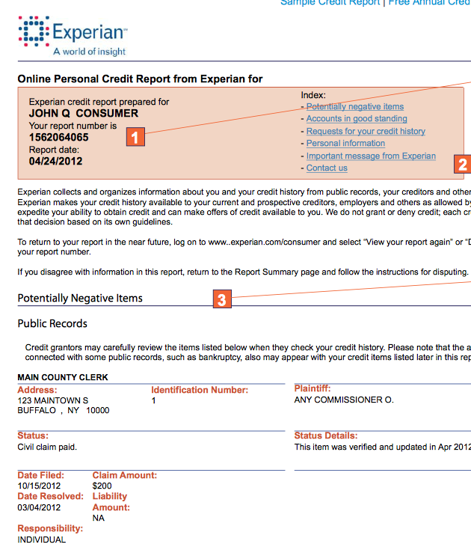
Leonard Gordon, an attorney and former Northeast Regional Director of the Federal Trade Commission, advises, “If you’ve been paying your bills on time and it shows that you are paying them late, you want to fix that. If there is anything inaccurate in your report, you should write letters to both the reporting agency and the creditor explaining why the report is in error. Attach documentation and send it by certified mail.”

Do not send the originals. Send copies, and keep a copy of everything that you send. You can find a sample letter at the end of this chapter.

THE CREDIT REPORTING COMPANY MUST INVESTIGATE
Once you complain, the credit reporting company, or credit bureau, must investigate. It usually takes about 30 days and they have to respond to you in writing to explain what they discovered. If there’s anything wrong, the company must make the changes and provide a free copy of the new report. You can also ask the credit bureau to send a copy of the new report to anyone who received your erroneous credit report in the previous six months.

ACCURATE NEGATIVE INFORMATION
You can’t make bad stuff go away quickly. If your credit report has negative comments and you have outstanding debts, there is no magic fix. Many companies advertise that they can help you improve your credit score. “That’s a lie,” says Herman De Jesus with the consumer advocacy group The New Economy Project in New York. He cautions, “We’ve seen a lot of people who have paid a large amount of money to these companies that promise a quick turnaround on the repair of their credit, and it’s never, ever happened.”

The only way to clean up your credit report is to pay your bills on time, and clear your previous debts. Your credit report changes all of the time, and will reflect your positive payment history, but it takes seven years to repair serious damage and restore your credit reputation.

CREDIT SCORE

What’s on that credit report is reflected in your credit score and that’s the key indicator for most lenders. The credit score is a statistical analysis of the information listed on the report. It takes into account how many credit cards you have, your outstanding debt as well as your payment history. It also considers how many times lenders have inquired about your credit, and how many times lenders have turned over your account for collections.

Most banks and lenders use the FICO Score, created by the Fair Isaac Corporation. Scores range from 300 to 850 and the higher the better. While banks consider 740 an A credit score, many banks will give mortgages to people who have scores of 580 and higher. But the score affects the kind of deal you get.

HOW THE CREDIT SCORE AFFECTS YOUR MORTGAGE

If your credit score is high you’ll get a lower interest rate. If it’s low and you’re still creditworthy you’ll pay a higher interest rate. Mike Copley, Senior Vice President of TD Bank, says, “If you have a lower FICO you are deemed more risky and the banks have to price in that element to protect themselves.”

The difference in interest rates can be significant. If you have a FICO Score of 780 to 850 and want to get a $300,000 mortgage, you will get a 1½ percent lower interest rate than if you had a 620 to 690 credit score. And that means you’ll save more than $104,000 over the life of a 30-year mortgage.

Once you understand your credit score, it’s time to assess your budget. “Before you go shopping for a home you have to know how much you have to spend,” says real estate attorney Adam Leitman Bailey, author of Finding the Uncommon Deal.

A banker, mortgage broker, or a counselor at a not-for-profit agency can help you determine what you can afford and pre-qualify you so that you know how much you can afford to pay each month and how much the lender will offer.

LIST OF THINGS YOU NEED:
- A record of all of your bank accounts.
- Estimate of the cash you have.
- Statements from any brokerage or bond accounts.
- Pay stubs and income verification.
5. Tax returns for at least the previous two years.

Even if you are just toying with the idea of getting mortgage or refinancing, it’s important to be careful about applying for credit.
Avoid making big purchases on credit and opening new credit cards the year that you apply for a mortgage because your payments on those accounts will reduce the amount banks are willing to lend you.

Kenneth Totten, Vice President and Chief Lending Officer of Metuchen Savings Bank in New Jersey, offers an excellent example: “If you have a $300 a month car payment, that will affect your ability to buy the house by about $60,000. If you were able to afford a $300,000 house, that goes down to $240,000 because you are driving around in a $300 a month car.”

SAMPLE LETTER TO CREDIT BUREAU

Date
Your Name
Your Address, City, State, Zip Code

Complaint Department
Name of Company
Address
City, State, Zip Code

Dear Sir or Madam:
I dispute the following information in my file. I have circled the items I dispute on the attached copy of the form that I received.
This item(s) (Identify the items in dispute. Give the name of the source such as creditors or tax court and identify the type of account - credit card or judgment, etc.) that is inaccurate or incomplete. (Describe what is inaccurate or incomplete and why.) I am requesting that the item be removed to correct the information.

Enclosed are copies of my documentation that supports my position. (Describe what you enclose: receipts, payment stubs, court records, etc.)
Please reinvestigate this matter (or these matters), and correct or delete the information as soon as possible.
Sincerely,

Your Name
Enclosures: List all the documents that you are enclosing.

CHAPTER TWO
HOW TO SHOP FOR A MORTGAGE

Banks have different approaches to lending. Some offer lower interest rates, and some have lower fees for their services. Some will negotiate with you and others won’t. But you have to do your own investigation and compare their deals before you sign the papers to take a mortgage with a lender.

MORTGAGE BROKERS
Many turn to mortgage brokers to do the legwork for them and they can be very helpful. Mortgage brokers don’t lend money but they generally have good contacts and know the marketplace. They know the current interest rates, what individual banks are offering and where you can get the best deal.
FEE FOR SERVICE
Mortgage brokers are in business and they charge a fee for their services and the fee will add to your borrowing costs.
Whether you use a broker or shop around yourself, it’s a good idea to know the basics.
TYPES OF MORTGAGES
You’ll have a range of options that include whether you want a 15-year fixed-rate mortgage, a 20-year, or a 30-year fixed-rate.

Your answer depends upon your age, your plans for the future and the home that you hope to buy. If you plan to live there for the rest of your life, then a 30-year mortgage may be better than a 15-year or 20-year

“With a 15-year mortgage you are typically going to get anyplace between three quarters and a half a point less interest rate,” explains Metuchen Savings Bank of New Jersey’s Kenneth Totten.
A 20-year-fixed rate mortgage offers a slightly higher interest rate than a 15-year. But overall you still pay less than you would for a 30-year mortgage.
To make the right decision, you have to analyze your needs. Totten suggests you ask yourself a couple of questions:
- How much can I afford to pay?
- Where am I going in the future?
He says, “If you are forty-eight years old and you are looking to retire when you are sixty-three, you probably don’t want to have a mortgage then. So you take the 15-year route.”

30-Year-Mortgage Is Most Common

Most people choose a 30-year fixed-rate mortgage for a good reason. You know what you will pay from the day that you borrow the money until the day that you pay it off. It offers security. “The consumer doesn’t really take much risk in a 30-year fixed-rate mortgage. The bank takes all the risk because it’s a long time,” says TD Bank’s Copley.
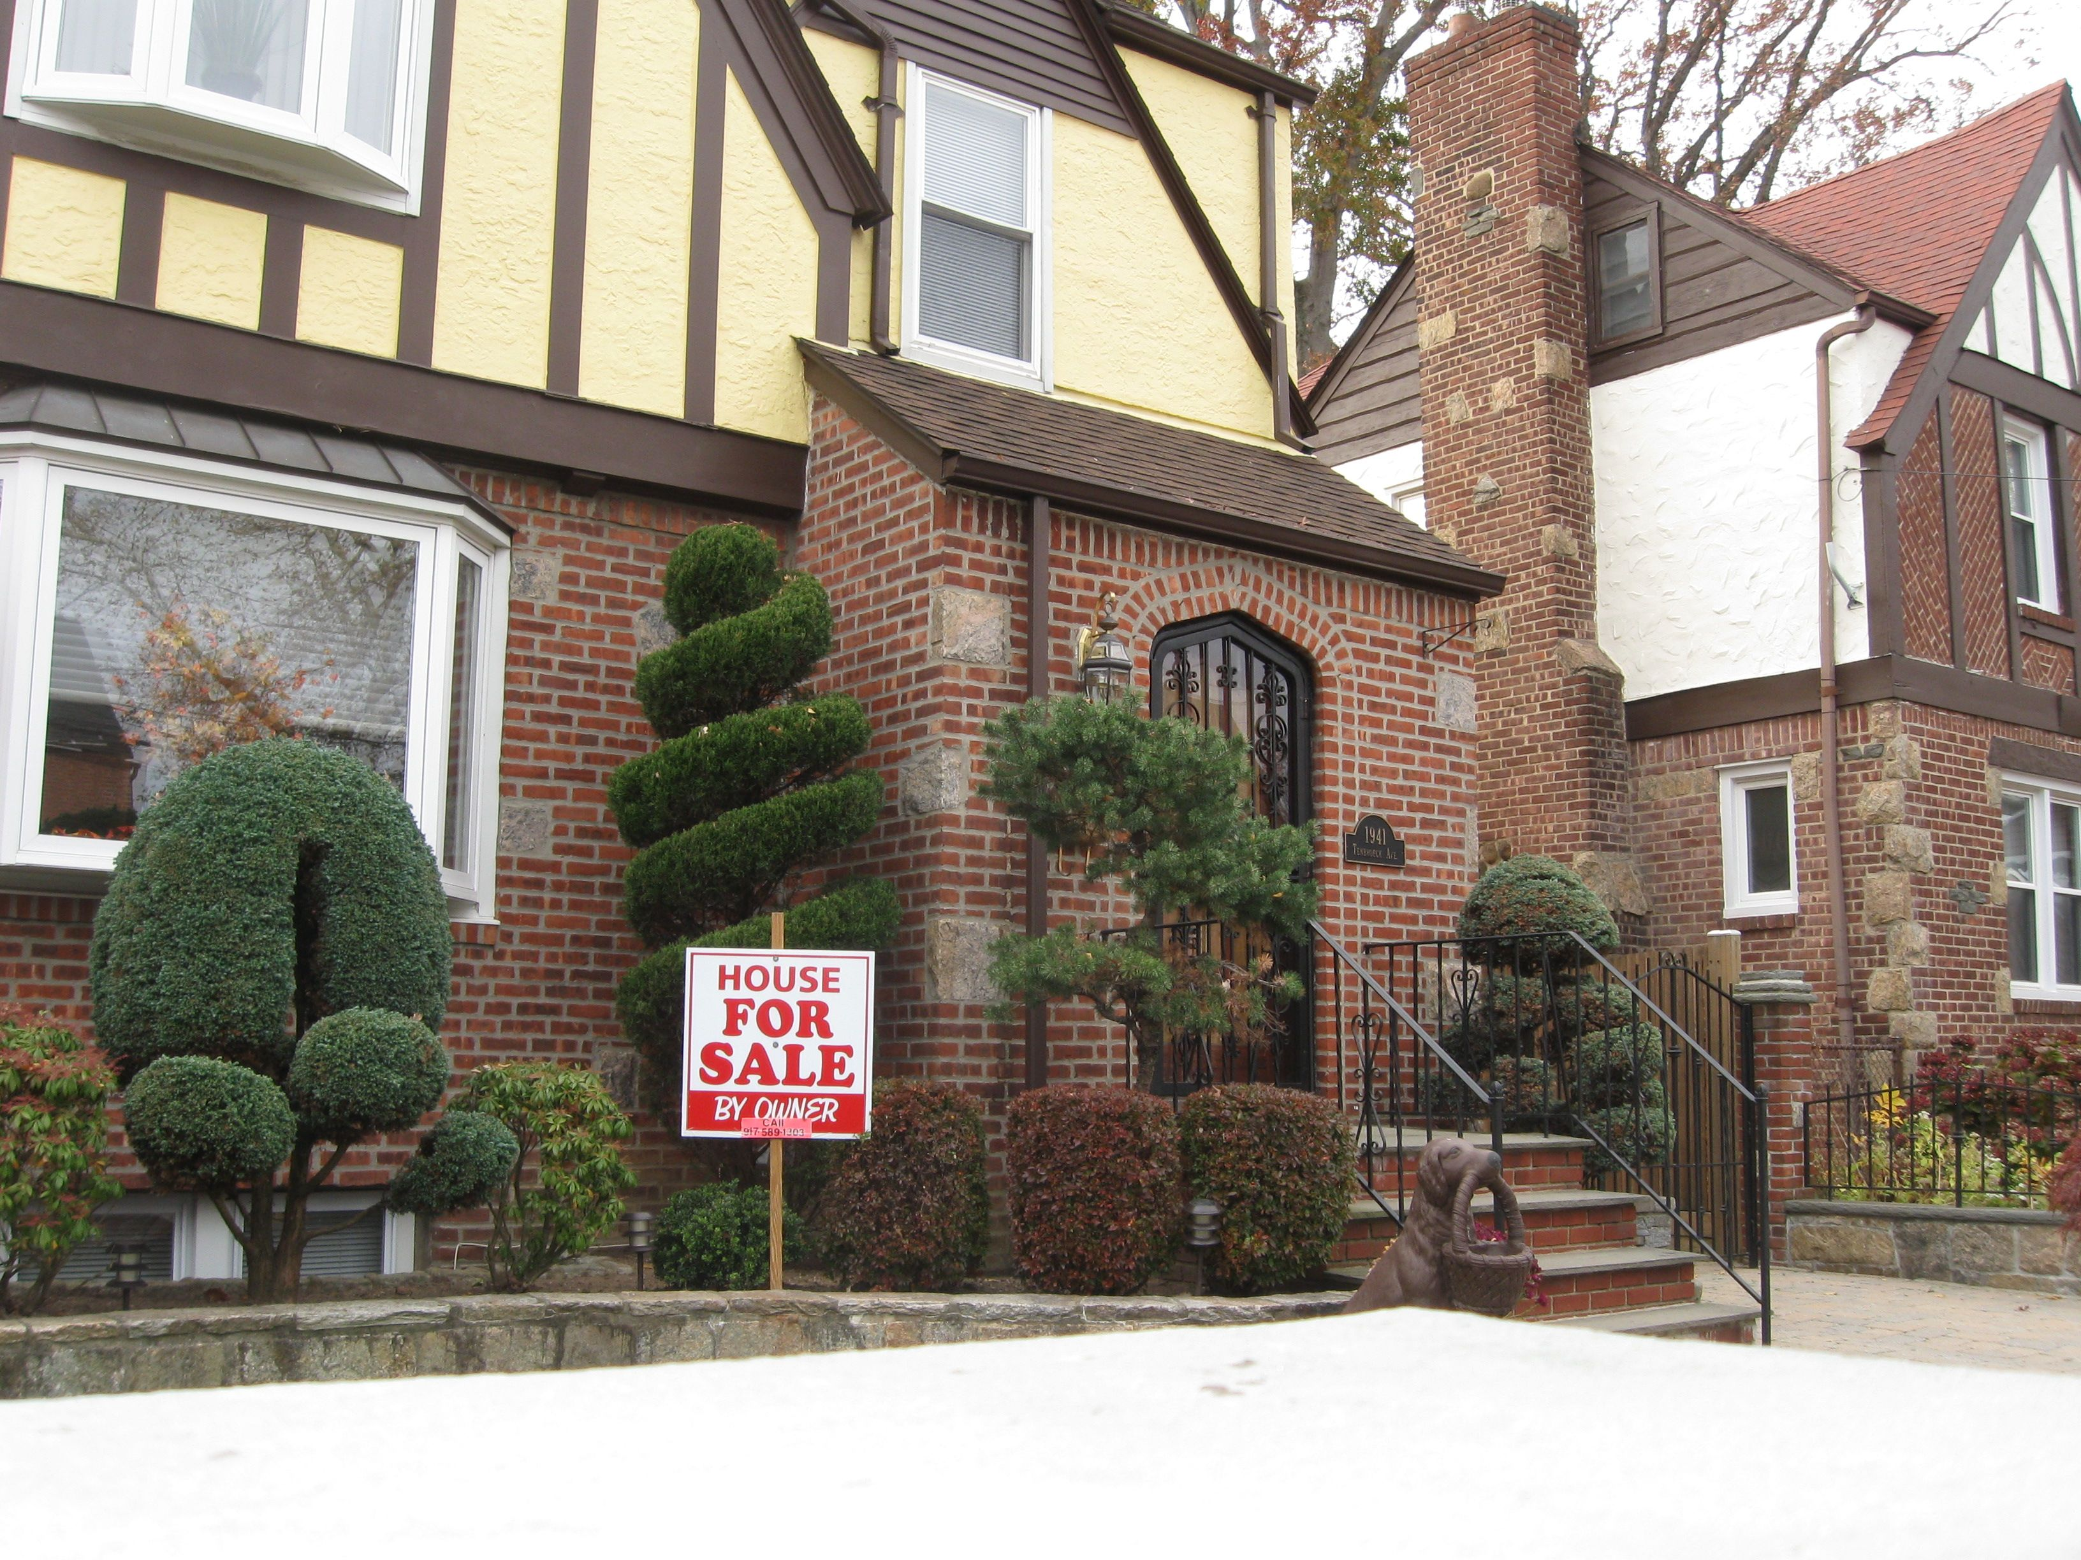

ADJUSTABLE RATE MORTGAGES

An adjustable-rate mortgage or “ARM” is riskier because the rate can go up and up.
“An adjustable-rate mortgage is a fixed-rate on the initial term and that can be from one to three, to five, seven or ten years. Thereafter the interest rate will usually adjust annually and sometimes monthly,” says Metuchen’s Totten. So an ARM is a gamble.
You’re betting that the interest rate won’t go up faster than the value of your property. And that’s why real estate attorney Adam Leitman Bailey discourages his clients from applying for adjustable-rate mortgages. “Do not get an adjustable-rate mortgage, period. Unless you are an expert in real estate or a trader on the stock market, don’t get one,” he insists.

Yet gambling works for some.

“If you are young and just starting out and you expect your income is going to increase and you are not going to be in this home for a long time, you may want to consider an adjustable-rate mortgage,” says Melissa Cohn of Manhattan Mortgage.
There’s also another benefit. Banks offer teaser rates to get your business and to make an adjustable-rate mortgage attractive. Financial advisor Lewis Altfest says, “A teaser rate can be a good rate if you are going to leave your home in a relatively short period of time.”
In other words, the gamble pays off if you sell your home before the rate goes up significantly. Still attorney Leitman Bailey is skeptical. “Don’t gamble,” he advises.

GOOD FAITH ESTIMATE
After you assess your needs and make a preliminary decision, the bank will give you a Good Faith Estimate with a rate quote. The Good Faith Estimate provides a clear picture of what the mortgage will cost over the long-term and lists the fees you’ll have to pay. When you have a “Good Faith Estimate” from one bank you can go shopping from bank to bank to see if you can get a better deal.

CREDIT CHECK CAUTION
But Totten says, “I would caution you, tell the banker what your credit score is. Do not let them run your credit again. Every time you pull your credit it has the impact of lowering your credit score.”

CHAPTER THREE

BEST MORTGAGE DEALS
Because owning your own home is a huge part of the American dream,
the federal government created programs to encourage home ownership.

The FHA, or Federal Housing Administration, a division of the Department of Housing and Urban Development or HUD, insures mortgage loans to give banks an incentive to lend you money.
This can be a great deal because if you qualify, you only need to put 3.5 percent down.
TD Bank’s Mike Copley says, “If you want to go with 3.5 percent down, your FICO score has to be a minimum of 580. If it is below that you have to come in with 10 percent.”

Others can help you assemble the down payment. “It could be gifted funds from friends and relatives. But it has to be gifted funds. It can’t be monies borrowed against a credit card,” explains HUD housing specialist Manny Alvarado.

YOUR INCOME
HUD uses a formula to determine if you have enough income to make your monthly payments. You can’t spend more than 31 percent of your monthly income on mortgage payments.
But if others will share the mortgage and financial responsibility with you, their income can be included in the calculation of that 31 percent. “You can have up to four people on an application. But they all have to be contributing to the household,” says Alvarado.

FHA INSURANCE

Bankers like FHA mortgages because the loans are insured, and there’s no risk to the bank if you can’t make your payments and default on the loan.

But to cover the cost of that insurance, FHA mortgages come with higher fees than most other types of mortgage loans. There is likely to be a 2.25 percent upfront premium that’s added to the loan. So, if you borrow $100,000 you have to pay another $2,250 back over time.

But FHA officials point out this is standard banking practice. HUD’s Alvarado says, “If you go to a lender and you come in with less than 20 percent, they are going to say you have to have private mortgage insurance. With us, we call it the mortgage insurance premium.

LIMIT ON MORTGAGE LOANS

FHA does not finance high-end homes. It limits the price of the home you can buy and that number varies from community to community. You can find out what HUD will finance in your area on http://www.hud.gov. Click on Buy a Home.

HUD also encourages you to visit its website to find a local housing counselor at a not-for-profit agency to help navigate the home buying process. You can find a list of housing counselors at http://www.hud.gov. Click on Resources and there’s a link to housing counselors.

VA LOANS

The Department of Veterans Affairs also insures mortgages. This is a great deal if you qualify, because you don’t put any money down. That means you get 100 percent financing.

USDA LOANS

The U.S. Department of Agriculture also insures loans in rural communities. This program is similar to a VA loan. You put no money down and you get 100 percent financing.

GRANTS
State and local governments often offer grants for down payment assistance and closing costs. In some areas a homebuyer can get as much as $25,000 toward the purchase of a home.

FREE MONEY
Some banks, including giants like HSBC, and regional and local banks like Astoria Federal Savings Bank in New York and Metchuen Savings Bank in New Jersey, offer free money through a program called The First Home Club. It was created by the Federal Home Loan Bank of New York, and you can find a complete list of participating banks in New York, New Jersey, Ohio and Connecticut at FHLBNY.

Kenneth Totten of Metuchen Savings Bank explains how it works at his bank and at others: “You set up a savings account and for every dollar that you save on a monthly basis there’s a four-to-one matching grant.”
Banks use The First Home Club to get you to bank and borrow with them. If you save $200 a month for ten months you get a grant of $7500 from the bank.
“That money is interest-free and it is forgivable over a five-year time frame. If you sell it (the home), you have to pay a portion of the money back, but only the principle. There is no interest being charged,” Totten says.

You are required to take a homeownership course at a HUD certified not-for-profit counseling agency before you’re approved to get the money. The participating banks want to make sure you know what homeownership entails. “Many people don’t know what they are getting into. They don’t know the expense of owning a home. It’s not just taxes, principal and insurance. You also have to pay for heat, water and electricity. If you own a house, if something breaks you have to fix it,” says HUD’s Manny Alvarado.
Housing counselors provide a reality check, and give you the information you need to succeed as a homeowner.

CHAPTER FOUR
MORTGAGE FEES

It costs money to get a mortgage. There are fees, fees and more fees. So it’s important to know what the fees are and what you’re paying for. The bank is required to tell you about these charges. Insist on getting the information.

GOOD FAITH ESTIMATE

“When you speak to a lender, the first thing you should do is ask for a Good Faith Estimate,” says Kenneth Totten of Metuchen Savings Bank. A Good Faith Estimate lists all of the fees. Peter Lucia, a loan officer with Mortgage Master in Tarrytown, New York, puts an exclamation point on that. “It’s important to know what these fees are going to cost you,” he says.

PRE-QUALIFICATION
The first fee is generally for pre-qualification and that should include a credit check. This clears the way by essentially pre-approving you to buy a home. You’ll learn exactly how much a bank is willing to lend you based on your income and your credit history.

APPLICATION FEES
Once you’re pre-approved and actually apply for a mortgage, you’ll pay an application fee. Application fees vary from $65 to $640 dollars depending upon the bank and where you live, according to the Federal Reserve Bank of New York.

MORTGAGE BROKER’S FEE
If you use a mortgage broker to pre-qualify you and help find a bank to lend you money, you’ll pay a broker’s fee of up to 3 percent of the mortgage.
Although the buyer usually pays the broker’s fee, sometimes the lender will pick up the cost. But if the bank pays the fee the mortgage broker is required to disclose the source.

LOAN ORIGINATION FEE
Once you’re pre-approved and choose a property, the lender can charge a loan origination fee to process and prepare the mortgage. It is generally $2,000 to $3,000.
APPRAISAL FEE
Before the bank approves the mortgage, it will hire an appraiser to see if the property is worth the sale price. The appraiser will set up an appointment with you or the homeowner to do an inside inspection of the home. The appraiser will also compare the physical aspects and the price of the home that you chose to others that sold recently in the same neighborhood.

The borrower generally pays the appraisal fee of $300 to $1,000. But try to negotiate with the bank or your broker. It’s possible that they will pick up the fee.

ATTORNEY AND NOTARY FEES
You’ll pay:
- The bank’s attorney $500 to $1,000.
- Notary fees of about $250.
- A document preparation fee for the bank to process the documents required.

TITLE SEARCH
You’ll also pay about $700 to $900 for a title search.
This is extremely important.
“A title company is going to be doing research on the property to make sure that there is not a claim in the future,” says Metuchen’s Kenneth Totten.

A claim might include a lien on the property by a plumber, a roofer, or anyone to whom the previous homeowner, or prior owners, owed money. If there’s a question about the title the bank may require you to purchase title insurance. That will protect you against any claims in the future.

ENGINEERING AND TERMITE INSPECTION
Banks often require an engineering inspection, and termite inspection. These are essential investigations to undertake before you buy a home.
“Do not buy without an engineer or an expert who can tell you about the systems of the house, how well it is built and what problems you are going to have when you step in,” advises attorney Adam Leitman Bailey.

PROPERTY SURVEY, WATER TESTS, FLOOD HAZARD INSPECTIONS

Some jurisdictions require a property survey, water tests and flood hazard inspections. The fees for all of these services usually range from $300 to $500 per expert. It’s money well spent because you learn exactly what you are getting into.

POINTS
A bank may ask you to pay points. “A point is an interest fee that you pay up front instead of paying it for the life of the mortgage,” says Metuchen Savings Bank’s Totten.
Generally a point is 1 percent of the amount you borrow. If you borrow $200,000, a point amounts to $2,000. The bank may charge points if your credit score is low.
Paying points can also give you a better deal on an interest rate. Totten says, “If interest rates were at 5 percent, and you had your heart set on playing 4¾ percent, you are going to be paying one point ahead of time for the right to pay less for the next 30 years.”

YOUR ATTORNEY

You pay for the bank’s attorney, but it is a good idea to hire your own lawyer to review the papers and represent you at the closing. That may cost another $500 to $1,000. Choose the attorney carefully. Leitman Bailey says, “Ask people who they used as their attorney and why. Ask deeper questions. Why did they like them? Why didn’t they like them?”

DISCLOSURE REQUIRED
Remember federal law requires banks and brokers to disclose all fees upfront. Make sure that they do and that you understand what you’re paying.

HOW TO GET A REVERSE MORTGAGE

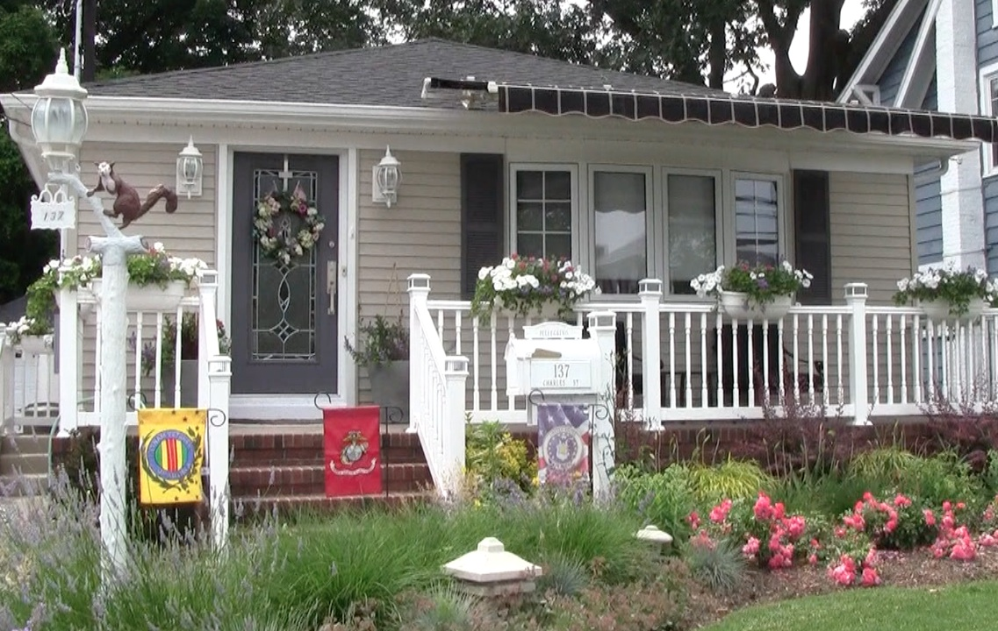

A reverse mortgage allows you to use your house as a piggy bank and borrow the money that you have built up in equity over the years that you’ve owned the home. But many consumer advocates think this is a dangerous way to use your real estate nest egg.
Yet if you need the money, understand the details and feel comfortable with the terms, it might work out for you.

AGE REQUIREMENT

If you are at least 62 years old and you’ve paid off your mortgage, or have a small mortgage remaining, it’s likely that you’ll qualify. “The reverse mortgage is the bank lending you your money,” explains Mike Copley, Executive Vice President of TD Bank. The FHA, part of the federal Housing and Housing and Urban Development Administration or HUD, has a reverse mortgage program and government officials think it’s useful. Manny Alvarado a HUD housing specialist says, “The older you are, the more you can borrow. You can get 50, 60 and up to 70 percent in some cases, depending upon how much equity you have.”

FHA-INSURED REVERSE MORTGAGES
FHA reverse mortgages offer some protection if the price of your home falls. HUD’s Alvarado says, “ A lot of the values on properties have gone down. With FHA we will insure that loan for the original amount that was made to the lender.”
You can find details about an FHA-insured reverse mortgage at http://www.fha.com/fha_reverse.cfm.

CONCERNS ABOUT HEIRS
Yet many worry their heirs will lose out if they use a reverse mortgage to borrow against their property. In some cases, heirs have the opportunity to repay the money. “If your children take over the house when you pass away, their only obligation is to get financing to pay off the reverse mortgage,” Alvarado says.

On the other hand, if you’ve taken a great deal of money out, it’s possible that your heirs will lose the property warns TD Bank’s Copley, “ There might not be enough equity to pass the home on. If there is not, the lender takes the home.”

FEES
Costly reverse mortgage fees are another negative because they take a big chunk of your money. Kenneth R. Totten, Vice President and Chief Lending Officer of Metuchen Savings Bank in New Jersey, says, “Fees can range anywhere from $8,000 to $16,000. Consumer advocacy groups are concerned that lenders take advantage of people who need money and use their homes for reverse mortgages. And there have been predatory fees associated with those types of mortgages.”

Many lenders no longer offer reverse mortgages. “We don’t offer reverse mortgages because we don’t think they are good for the consumer,” explains TD Bank’s Copley.
So if you are thinking of using your home to get cash, it’s important to study the details. Attorney Leonard Gordon former Northeast Director of the Federal Trade Commission, cautions, “It is just important with any financial transaction to take your time and avoid high-pressure sales tactics and to understand what you are getting into.”

